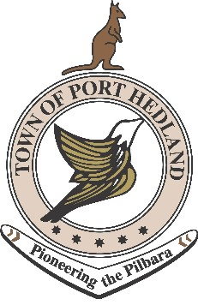

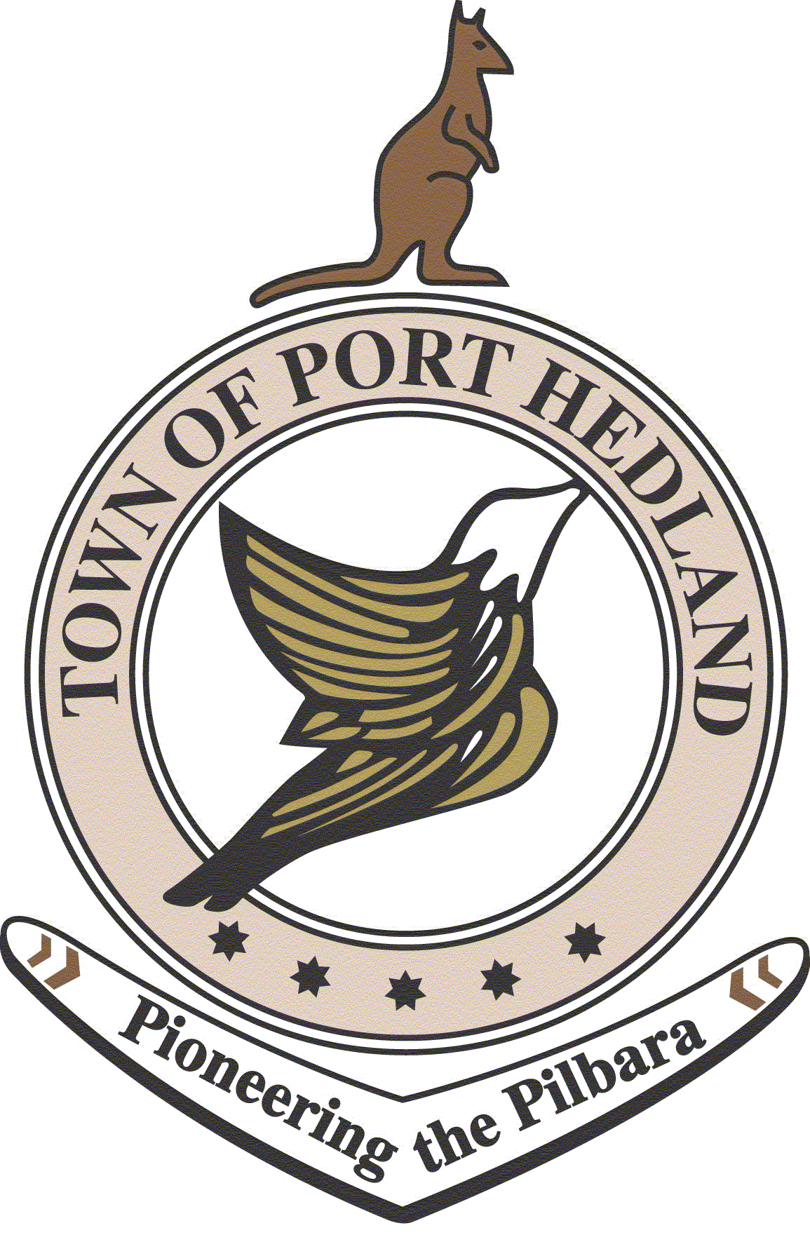
MEETING AGENDA

Aboriginal Consultation Forum
THE VALUE OF SPORT AND RECREATION AND HOW IT TIES INTO A HEALTHY LIFESTYLE

MONDAY 20TH JULY 2015

9:30 AM – 1:00 PM

LOTTERIES HOUSE, SOUTH HEDLAND

9:30 | Acknowledgement to country and welcome | Maureen Kelly
9.32 | Enrol to vote – Have your say | Grace Waugh (ToPH)
9.40 | Update on current Sport and Recreation Opportunities/Programs/Services of benefit to the community  - Planning/Facilities/CDO/Kidsport  - Indigenous Sports Program – Past, present, future  - Aboriginal Liaison Officer introduction  - Sport and Recreation - health and lifestyle benefits to community | Graeme Hall (ToPH)  Morgan Mair (DSR)
10.10 | Best Practice  - The Slam  - South Hedland Primary School Football Program  - Shooting Goals, Net/Set/Go (Netball)  - Kicking Goals Football Program | Daniel Murphy (ToPH)  Darryl Mansfield (Principal SHPS)  TBC  Shane Beros (Teacher SHHS)
10:30 Morning Tea

10.45 | Maximizing the Positives of Sport and Recreation Opportunities and Participation  Group Exercise:  What role can you and an individual or organisation do to improve the accessibility for the community in sport and recreation program and services in Port Hedland? | Maureen Kelly to facilitate
11.45 | Agree on topic for next forum  Next meeting date – TBC | Maureen Kelly
12:00
Lunch & Networking

