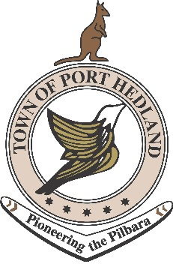

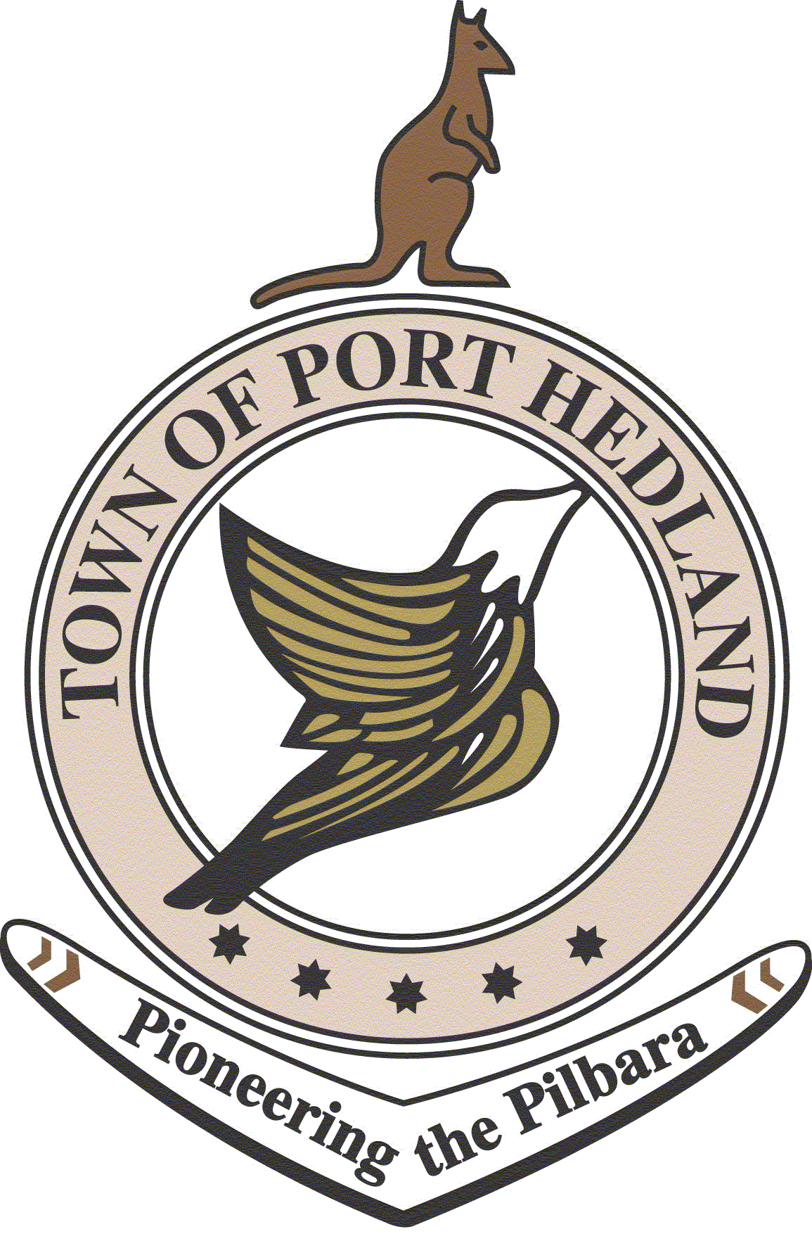
MEETING AGENDA

Aboriginal Consultation Forum
Services and Programs in 2015

MONDAY 23 February 2015

09:30 AM – 1:00 PM

LOTTERIES HOUSE, SOUTH HEDLAND

9:30 | Introduction / Aim of Forum  - Opportunity for anonymous questions | Maureen Kelly
9:45 | Summary of organisations in attendance  - Opportunity for anonymous questions | All
10:00 | Café style session  - Sharing of issues / protocols | All
10:15
Morning Tea

10:30 | Networking / speed dating style session | All
11:30 | Whole Group Debrief / Feedback | All
11:45 | Agree on topic for next forum  Next meeting date – Monday 25 May 2015 | Maureen Kelly
12:00
Lunch & Networking

