Aboriginal & Torres Strait Islander Consultation Forum

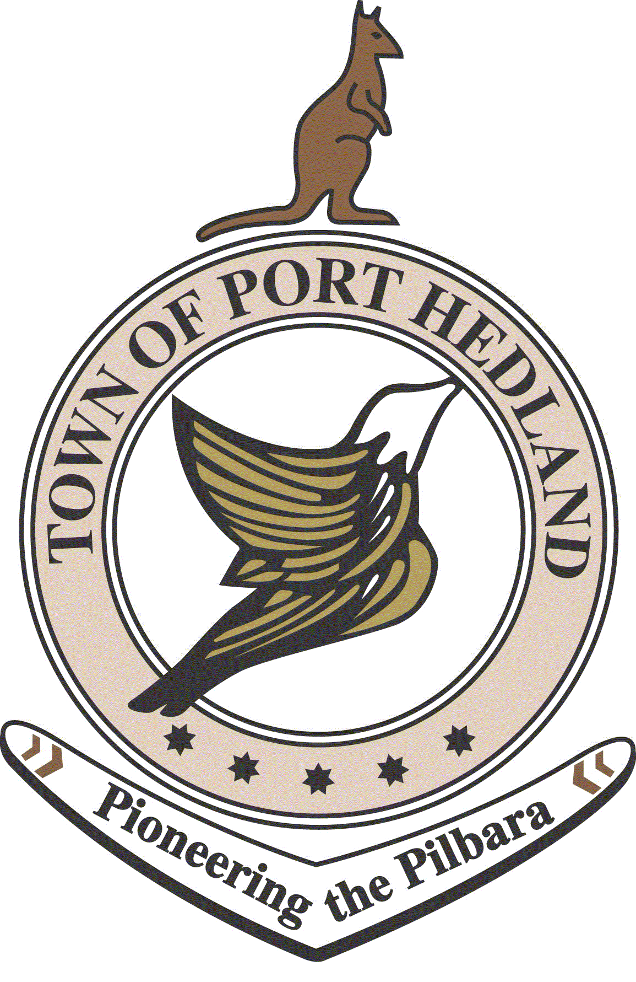
MEETING AGENDA

Drugs & Alcohol in the Community, Part 2

Wednesday 23 November 2016, 9:30 AM – 1:00 PM

LOTTERIES HOUSE, SOUTH HEDLAND

9:30 | Acknowledgement of country and welcome | Maureen Kelly
9:35 | Presentation by Mission Australia (re. services provided) | Mission Australia
9:40 | Updates  Mayor Camillo Blanco (5 minutes)  Snr Sgt Dean Snashall (5 minutes)  Hon. Stephen Dawson MLC (3 minutes)  Any Further Updates (5 minutes) | (facilitated by Maureen Kelly)
10:00 | Background and History of Local Services  Alfred Barker (Kariyarra Elder) | Alfred Barker
10.10 | - Regional Services Reform Unit  - -All reforms ongoing in the Pilbara including ‘Turnpoint Pilbara’ (Regional Alcohol and other Drug strategy.) | Regional Services Reform Unit
10:30 - Morning Tea
10:45 | - Aboriginal Consultation Forum Location | T Stoddart
10:50 | Collaborative working approaches going forward regarding alcohol and other drugs in our community.  - - Small groups discuss key areas and points of collaboration  - -Whole group discussion | All (facilitated by Maureen Kelly)
11:25 | Learnings & Way Forward  All participants will brainstorm what actions have been identified and responsible parties | All (facilitated by Maureen Kelly)
11:45 | Agreed Actions and Meeting Closing | Maureen Kelly
11.50 | Agree on topic for next forum  Next meeting date – Tuesday 14 February 2017
12:00 - Lunch & Networking

